IAP M3 — Domain Model and AI Critique
EECE-4081-002 Software Engineering — Fall Term 2026
Caleb Adonai Turris
Repository: github.com/WoodlandMoss/iap-project-setup
Deliverables folder: assignments/IAP M3 - Domain Model and AI Critique/

1. The AI's First Draft (Unedited)
Prompt given (cold, first attempt, requirements attached in full):
Here are the requirements for my app [REQUIREMENTS.md pasted in full]. Draft a domain model for it as a Mermaid ER diagram.
Response — kept verbatim below, exactly as produced, before any edits:
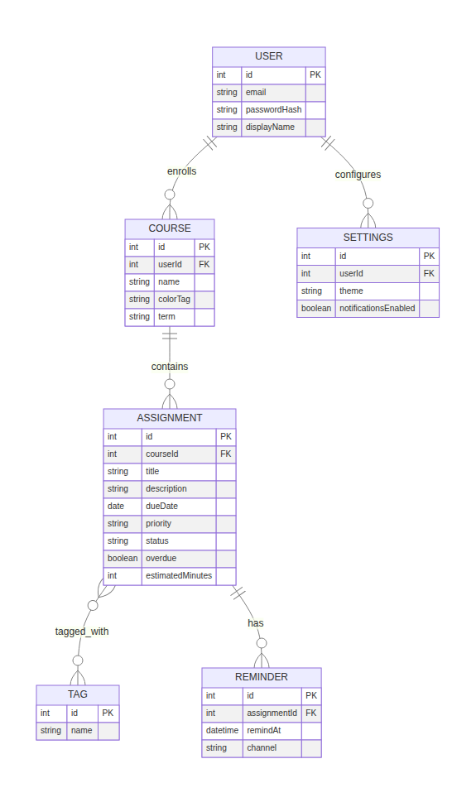
Figure 1. AI's unedited first-draft domain model (domain-model-raw.png).

Mermaid source (domain-model-raw.mmd)
erDiagram
USER ||--o{ COURSE : enrolls
COURSE ||--o{ ASSIGNMENT : contains
ASSIGNMENT }o--o{ TAG : tagged_with
ASSIGNMENT ||--o{ REMINDER : has
USER ||--o{ SETTINGS : configures
USER {
int id PK
string email
string passwordHash
string displayName
}
COURSE {
int id PK
int userId FK
string name
string colorTag
string term
}
ASSIGNMENT {
int id PK
int courseId FK
string title
string description
date dueDate
string priority
string status
boolean overdue
int estimatedMinutes
}
TAG {
int id PK
string name
}
REMINDER {
int id PK
int assignmentId FK
datetime remindAt
string channel
}
SETTINGS {
int id PK
int userId FK
string theme
boolean notificationsEnabled
}
Six entities, five relationships: a USER who owns multiple COURSEs, each COURSE containing multiple ASSIGNMENTs, ASSIGNMENTs tagged through a many-to-many TAG join, ASSIGNMENTs owning REMINDERs, and a USER configuring one SETTINGS row. This draft was not edited before being saved — the critique in Section 3 evaluates it against the adopted model below.

2. The Adopted Domain Model
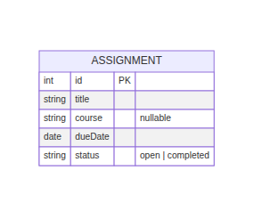
Figure 2. Adopted domain model (domain-model.png).

Mermaid source (domain-model.mmd)
erDiagram
ASSIGNMENT {
int id PK
string title
string course "nullable"
date dueDate
string status "open | completed"
}

Why this is the whole model
One entity, five attributes. Every attribute traces to a specific line in REQUIREMENTS.md:
Attribute | Traces to
id | US-1: "it is saved and returned with a unique ID"
title | US-1 (required — HTTP 400 if omitted)
course | US-1 ("optionally a course"), US-4 (filter by course) — nullable
dueDate | US-1 (required, ISO-8601), US-2 (sort key), US-8 (overdue comparison)
status | US-3 (open/completed), US-5 (filter by status)

Two deliberate omissions, both load-bearing:
- No overdue column. US-8's acceptance criteria describe it as a comparison made at view time ("when I view the list, then its returned record includes overdue: true"), not a fact recorded once. An assignment becomes overdue purely because time passed, with no write to the row — storing it would silently go stale between requests. It's a computed property of (dueDate, status, now), not a column.
- No COURSE entity. Nothing in US-1 through US-8 creates, edits, lists, or deletes a course independently of an assignment. US-4 only ever supplies a course name to filter by. Promoting it to its own table would add a foreign key and referential-integrity questions (what happens to a COURSE row when its last assignment is deleted?) that no requirement asks for.

3. Written Critique — AI Draft vs. Adopted Model
Source: domain-model-raw.mmd (AI's unedited first draft, 6 entities). Compared against: domain-model.mmd (adopted model, 1 entity). Compared to: REQUIREMENTS.md.

Where it over-modelled
- USER. The draft invented an entity with email, passwordHash, and displayName — full authentication. REQUIREMENTS.md's own "Need and Justification" section names the stakeholder as "primary user and sole stakeholder (developer of this app)"; none of US-1 through US-8 mentions logging in, registering, or any per-user data isolation. This is the same multi-user assumption the M2 elicitation audit already flagged and ruled out (ELICITATION_AUDIT.md, item 1) — the draft repeated it at the modeling stage even with the scoped requirements as direct input.
- COURSE as a first-class entity. The draft gave COURSE its own PK, a userId FK, and fields (colorTag, term) no story requests. US-4 is the only story that touches course at all, and it treats course as a string to filter by — nothing creates, edits, or lists courses on their own. Modeling it as a related table implies CRUD and referential-integrity behavior (e.g., what happens to an empty COURSE row) that isn't specified anywhere.
- SETTINGS. theme and notificationsEnabled correspond to no requirement. Nothing in the NFRs or user stories mentions preferences.
- REMINDER. A full entity with remindAt and channel for a feature — reminders/notifications — that ELICITATION_AUDIT.md (item 2) already named as an invented, out-of-scope feature during M2. Reappearing here means the constraint didn't carry forward into the modeling prompt.
- TAG plus a many-to-many join. No user story mentions tagging or categorization beyond the single course field.
- Extra ASSIGNMENT fields: description, priority, estimatedMinutes. None are read or written by any of US-1–US-8; they're the same "priority level" and "estimated time" fields the M2 elicitation audit already flagged as invented (ELICITATION_AUDIT.md, item 11).

Where it under-modelled
- No required/optional distinction. US-1's acceptance criteria are explicit: omitting title or dueDate returns HTTP 400 (NFR-3), while course is optional. The draft's ER attributes don't distinguish nullable from required columns anywhere — every field is listed flat, with no constraint notation, so the one piece of validation logic the requirements actually specify (which fields are mandatory) doesn't show up in the model at all.

Where it invented a relationship with no basis
- USER ||--o{ COURSE : enrolls. "Enrolling" implies a multi-user classroom model (students enrolling in shared courses) that contradicts the single-user, single-stakeholder framing stated directly in REQUIREMENTS.md.
- ASSIGNMENT }o--o{ TAG : tagged_with. A many-to-many relationship built on an entity (TAG) that itself has no requirement backing it — there's no basis for the entity, let alone the relationship's cardinality.

Where it was right
- ASSIGNMENT as the central entity. Correctly identified as the one entity every user story revolves around — this part needed no correction.
- dueDate as a date, status as a string. Both types match how REQUIREMENTS.md describes them (ISO-8601 calendar date; a small fixed set of state values). The adopted model keeps both unchanged from the draft.
- Giving ASSIGNMENT its own PK independent of any parent. Even though the draft wrongly nested ASSIGNMENT under COURSE via a foreign key, the instinct that assignments need a stable identity of their own (not just a position in a list) was correct and is preserved in the adopted model.

Judgment
Five of six entities in the draft don't survive contact with REQUIREMENTS.md. The pattern matches the M2 elicitation audit almost exactly — the model reaches for a generic, multi-tenant SaaS shape (users, settings, notifications, tags) by default, even when handed the actual scoped requirements as input, rather than deriving structure only from what those requirements say. The one part of the draft that survives (a single ASSIGNMENT entity, correctly typed on dueDate and status) is exactly the part that traces directly to a user story. Everything that doesn't trace to a story — USER, COURSE, SETTINGS, REMINDER, TAG, and the extra ASSIGNMENT fields — got cut. The adopted model is what's left after that cut: one table, five columns, matching the five things the requirements actually ask the system to store.

4. Prompt-and-Diff Log (Milestone 3)
Prompt 1 (AI's first draft, cold, requirements attached):
Here are the requirements for my app [REQUIREMENTS.md pasted in full]. Draft a domain model for it as a Mermaid ER diagram.
Response: Produced a 6-entity model — USER, COURSE, ASSIGNMENT, TAG, REMINDER, SETTINGS — with a USER-owns-COURSE-contains-ASSIGNMENT hierarchy, a many-to-many ASSIGNMENT/TAG join, and extra ASSIGNMENT fields (description, priority, estimatedMinutes) not present in any user story.
Diff: Added domain-model-raw.mmd and DOMAIN_MODEL_RAW.md (kept verbatim, unedited, as evidence).

Prompt 2 (adopted model, separate pass):
Reduce that draft to only what REQUIREMENTS.md's user stories actually require, tracing every entity and attribute back to a specific story or NFR.
Response: Collapsed the model to a single ASSIGNMENT entity (id, title, course, dueDate, status), dropping USER, COURSE, SETTINGS, REMINDER, and TAG as unsupported by any requirement, and explicitly excluding overdue as a stored column since US-8 defines it as a comparison made at read time, not a persisted fact.
Diff: Added domain-model.mmd, DOMAIN_MODEL.md, and DOMAIN_MODEL_CRITIQUE.md (critique of the M3-Prompt-1 draft against the adopted model — over-modelling, under-modelling, invented relationships, and what it got right).
Commit: de87c0d — M3: domain model and AI critique

